**The last time human beings landed on Moon, by far**

Probably all people know the mission of Apollo 11 and the famous “*That's one small step for a man, one giant leap for mankind.*” by Neil Armstrong. However, not a lot of people are familiar with the mission of Apollo 17, the last time human beings landed on the Moon.

What is there on the moon is probably one of the oldest questions of mankind. Humans could only guess through fantasy before, but in the 1960s, the United States decided to start exploring the moon, and the Apollo project was born. There are a total of 15 Apollo spacecrafts to implement the plan, of which, the last time it was Apollo 17.

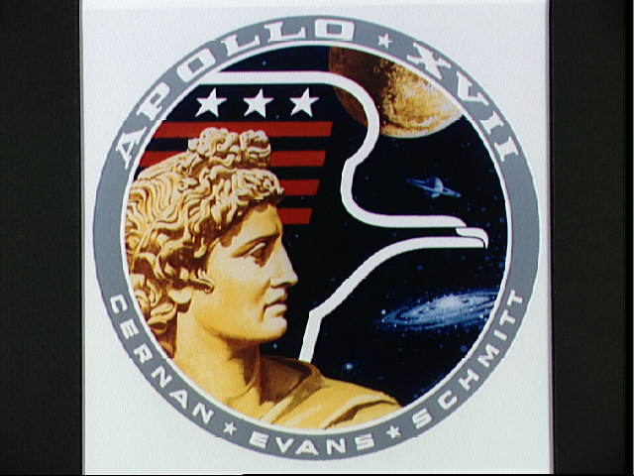

Insignia of Apollo 17

**Mission Timeline**

*Launching*

Apollo 17 was launched at the night of 07 Dec 1972, making it the only night launch in the whole Apollo series. Nearly 500,000 people around the world were estimated to have watched the streaming of this launch. Two days later, on December 10, the engine of **command and service module** (**CSM**) slowed down, bringing the CSM stack into lunar orbit.

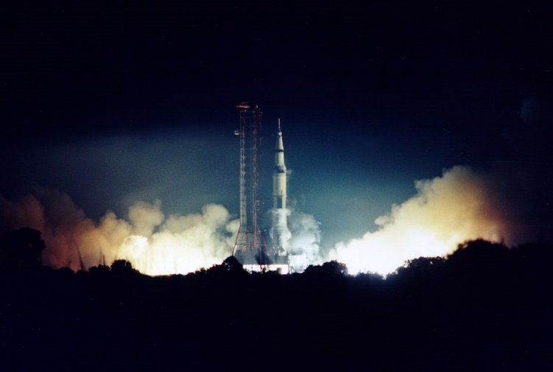

launching

*Moon landing*

This time, the Lunar Module (LM) was built to separate with the CSM, and brought our crew, Eugene Cernan and Harrison Schmitt, to and back from the Lunar, while Evans stayed at the CSM doing space experiments. After separating from the CSM, the crew began to descent for the landing to Taurus-Littrow. The LM landed on the lunar surface at 2:55 pm EST on December 11.

https://history.nasa.gov/alsj/a17/a17.landing.mp4

*Lunar surface*

Three moonwalks(EVAs) were scheduled in Apollo 17. The astronauts gathered 14 kilograms of samples, took seven gravimeter measurements, and deployed two explosive packages(wiki pedia) at their first EVA on 11th Dec. While at the second EVA on 12th Dec., the crew made a record of the longest-duration EVA in history to-date, which was seven hours and thirty-seven minutes. On their last EVA on 13th Dec., the astronauts gathered 66 kilograms of samples, and Gene Cernan made the famous expression: ... I'm on the surface; and, as I take man's last step from the surface, back home for some time to come - but we believe not too long into the future - I'd like to just [say] what I believe history will record. That America's challenge of today has forged man's destiny of tomorrow. And, as we leave the Moon at Taurus-Littrow, we leave as we came and, God willing, as we shall return, with peace and hope for all mankind. "Godspeed the crew of Apollo 17."[38]

*Return to Earth*

The LM left the Lunar and reconnected to the CSM on December 14, and after 5 days of travelling, the Apollo 17 spacecraft successfully landed back on Earth on December 19.

**Mission Objective**

One of the object for Apollo 17 was to bring back some rocks older or younger than the rocks the NASA already had from the earlier missions. That’s why the Taurus-Littrow area was picked as the landing site from this mission. The astronauts didn’t let the NASA down. They brought back 111kg rocks from the Moon.

Also, Like Apollo 15 and Apollo 16, Apollo 17 was a "[J-mission](https://en.wikipedia.org/wiki/List_of_Apollo_missions#Alphabetical_mission_types)", meaning that the astronaunts would stay at the lunar for 3 days and use the Lunar Roving Vehicle.

There were other scientific objectives of the Apollo 17 mission like geological surveying and sampling of materials of the Taurus-Littrow region; deploying and activating surface experiments; and conducting in-flight experiments and photographic tasks during lunar orbit and transearth coast(NASA, https://www.nasa.gov/mission_pages/apollo/missions/apollo17.html).

**Crew**  
Eugene A. Cernan, Commander, pic  
Harrison H. Schmitt, Lunar Module Pilot, pic  
Ronald E. Evans, Command Module Pilot, pic

**Backup Crew**  
John W. Young, Commander  
Charles M. Duke Jr., Lunar Module Pilot  
Stuart A. Roosa, Command Module Pilot

**Fun Facts About Apollo 17**

During lunar surface operations, Commander Cernan always drove the rover, while Lunar Module Pilot Schmitt was a passenger who assisted with navigation(wiki pedia).

Harrison H. Schmitt  remains the only professional scientist to have flown beyond low Earth orbit and to have visited the Moon(https://en.wikipedia.org/wiki/Harrison_Schmitt).

As the name might suggest, Mr Cernan is of Czechoslovak descent. Indeed, he carried Czechoslovakia’s flag with him on his final space flight(<https://english.radio.cz/us-astronaut-czechoslovak-descent-recalls-moon-landings-and-pioneering-spacewalk-8594969>).

**Documentations about Apollo 17**

If you are interested, here are some video/audios you may interested.

The Apollo Experience: Apollo 17 - Part One (NASA Documentary) | Timeline

<https://www.youtube.com/watch?v=vIGbOoZzlYI&t=1039s>

The Apollo Experience: Apollo 17 - Part Two (NASA Documentary) | Timeline

<https://www.youtube.com/watch?v=SQOEC9gHpmA>

Outbound to Camelot-- They are now on Surface 4-7 and will start the final depressurization

https://www.hq.nasa.gov/alsj/a17/a17a1403501.ra

Back to home

Reference

Seskus, T. (2020, October 11). *Winter is coming — and that could be good news for Alberta's natural gas sector*. CBC News. <https://www.cbc.ca/news/business/alberta-natural-gas-outlook-1.5755648>

Last Name, First Initial. Second Initial. or user name of person or group who uploaded the video. (Year video was posted, Month Day). Title of video [Video]. Website name. URL

**Examples**

Timeline - World History Documentaries. (2018, February 20). The Apollo Experience: Apollo 17 - Part One (NASA Documentary) | Timeline [Video]. YouTube. <https://www.youtube.com/watch?v=vIGbOoZzlYI&t=1039s>

Timeline - World History Documentaries. (2018, February 22). The Apollo Experience: Apollo 17 - Part Two (NASA Documentary) | Timeline [Video]. YouTube. https://www.youtube.com/watch?v=SQOEC9gHpmA&t=1s